Weather explains interannual variability, but not the temporal decline, in insect biomass

François Duchenne*1

*1Swiss Federal Institute for Forest, Snow and Landscape Research (WSL),* *8903 Birmensdorf, Switzerland*

[francois.duchenne@wsl.ch](mailto:francois.duchenne@wsl.ch)

*: corresponding author, [francois.duchenne@wsl.ch](mailto:francois.duchenne@wsl.ch%20)

ARISING FROM J. Müller et al. *Nature* [https://doi.org/10.1038/s41586-023-06402-z](https://doi.org/10.1038/s41586-023-06402-z%20) (2023)

**Competing interests statement:**

The author declares no competing interests.

**Author contributions:**

FD performed the analyses and did the figures and wrote the manuscript.

**Code availability statement:**

The R code to perform the analyses are provided as supplementary material.

**Data availability statement:**

The data are available with the original publication, [https://doi.org/10.1038/s41586-023-06402-z](https://doi.org/10.1038/s41586-023-06402-z%20).

# Main

In a recent publication1, Müller *et al.* re-analysed, in light of new data, the dataset of the highly cited paper of Hallmann *et al.*2, who showed a strong decline in insect biomass in Germany between 1989 and 2016. Müller *et al.* first show that adding recently collected data (2016-2022) to Hallmann *et al.* time series, results in a non-significant decline in biomass between 1989 and 2022. Second, they present a re-analysis of the data from Hallmann *et al.* adding weather conditions as predictors and conclude that the temporal variations in insect biomass are explained by weather conditions only. Here I present arguments that explain why I think their analysis was unsuitable to draw such conclusions, because of the limitations of the dataset and because of flawed statistical analyses. More appropriate analyses produce a pattern opposite to the main message of Müller *et al.*: there is a significant temporal decline in insect biomass that is not explained by weather conditions and habitats conditions played a significant role in the observed decline.

## Interpretation of Figure 1 was misleading

First, figure 1 of Müller *et al.* is misleading because it exhibits two datasets collected on different geographic areas, as shown by their Extended Data Fig. 1, as a unique time series. The 1989-2016 data used by Müller *et al.* to fit their model, were mostly collected in middle-west Germany, while the 2016-2022 data, used to validate the model, were collected in south-east Germany (Fig. 1). In the review process documentation available with the paper, Müller *et al.* stated that they have no reason to expect any difference between these two areas in terms of average insect biomass because of two reasons: there is a strong overlap on of biomass values on the unique year of overlap of both datasets and previously they did not find any change in biomass between semi-natural and agricultural dominated landscapes. However, it would have been easy to test for a putative difference in average biomass of insects between the validation and training datasets before interpreting them together.

To test for it, we used a modified version of their log-gaussian General Additive model (GAM) to test for difference in biomass between validation and training dataset, while accounting for weather conditions, temporal trend, spatial autocorrelation, phenology and site-random effects. We found a significant and strong difference between both datasets (Fig. 1d), suggesting that both area exhibit difference in average biomass that is likely to be driven by difference in the regional context, because it is not driven by the weather or the remaining temporal trend. Areas in which the data of Hallmann *et al.* were collected are more anthropized than the areas in which recent data were collected (Fig. 1b-c). This difference alone could explain the apparent increase in insect biomass in recent data.

The use of two independent datasets to train and validate their model, is a strength of Müller *et al.*’s work, but these datasets should not be compared with each other to extrapolate temporal trends without accounting for spatial differences. However, the authors take few precautions to interpret this heterogeneous time series: “*The temporal pattern of the compiled data shows that the linear decrease reported by Hallmann et al. throughout 2016 did not continue in more recent years, but instead biomass increased from 2016 until 2022, with highest values similar to those from the late 1980s reached in 2022 (Fig. 1).”*.

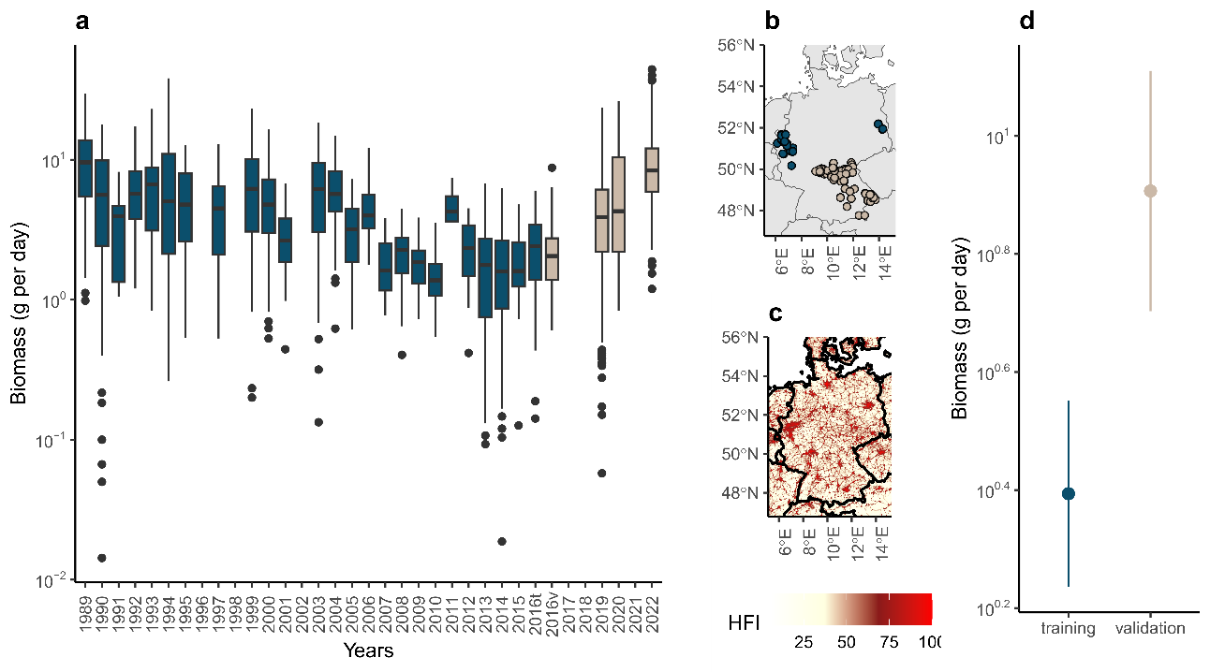***Fig. 1: Misleading presentation of the initial and new datasets for insect biomass.*** *Data from Hallmann et al. (blue, training dataset in Müller et al.) and more recently collected data (beige, validation dataset in Müller et al.) were presented by Müller et al. on the same time series (a), while they were collected in different geographic areas (c), with different levels of disturbances (d, Human Footprint Index v2 1995-2004). (d) Average (±CI95%) biomass values as a function of the dataset, predicted by a GAM accounting for spatial autocorrelation, site random effects, time and weather conditions. The significant difference shows that these datasets are not comparable, and that the increase in biomass on 2016-2022 relative to 1989-2016 could be due to the difference in sampling region.*

## Weather conditions is not the only driver of temporal changes in insect biomass

Second, Müller *et al.* argue that weather conditions were the only driver of temporal changes in insect biomass, because when weather conditions were included in their model, there was no remaining temporal trend in the residuals of the model (model 5 of their study). Their analyses clearly show that climatic conditions have a major impact on insect biomass. However, Müller *et al.* did not control for missing drivers of insect biomass in their model, while, as in all ecological studies, the list is long, including for example the use and toxicity of pesticides3,4. One way to do so would be to account for a remaining temporal trend, not in the residual as authors did, but directly in the model used to model insect biomass. Estimating the temporal trend in the residuals, is a hierarchical approach that is highly biased: the model first absorbs all the variation possible with weather data before the authors look for a remaining temporal trend. Since there is a known temporal trend in weather conditions themselves (aka climate change), the statistical fit, which seeks to explain as much variance as possible with the available variables, is likely to attribute any temporal change in insect biomass to temporal changes in weather conditions. Thus, the absence of temporal trend in the residuals is not informative on the importance of non-modelled drivers.

When I estimated both a temporal trend in insect biomass and the effects of weather conditions simultaneously, by simply adding a linear year effect to Müller *et al.*’s model, I found opposite results, while improving the fit of the model (lower AIC, Table 1). I estimated a significant decline of biomass over time (-4.0%.year-1) that was not explained by weather conditions (Fig. 2 and Table 1). This temporal trend is not informative of the possible drivers of the temporal decline but indicates that insect biomass declined by 4% per year because of unknown factors.

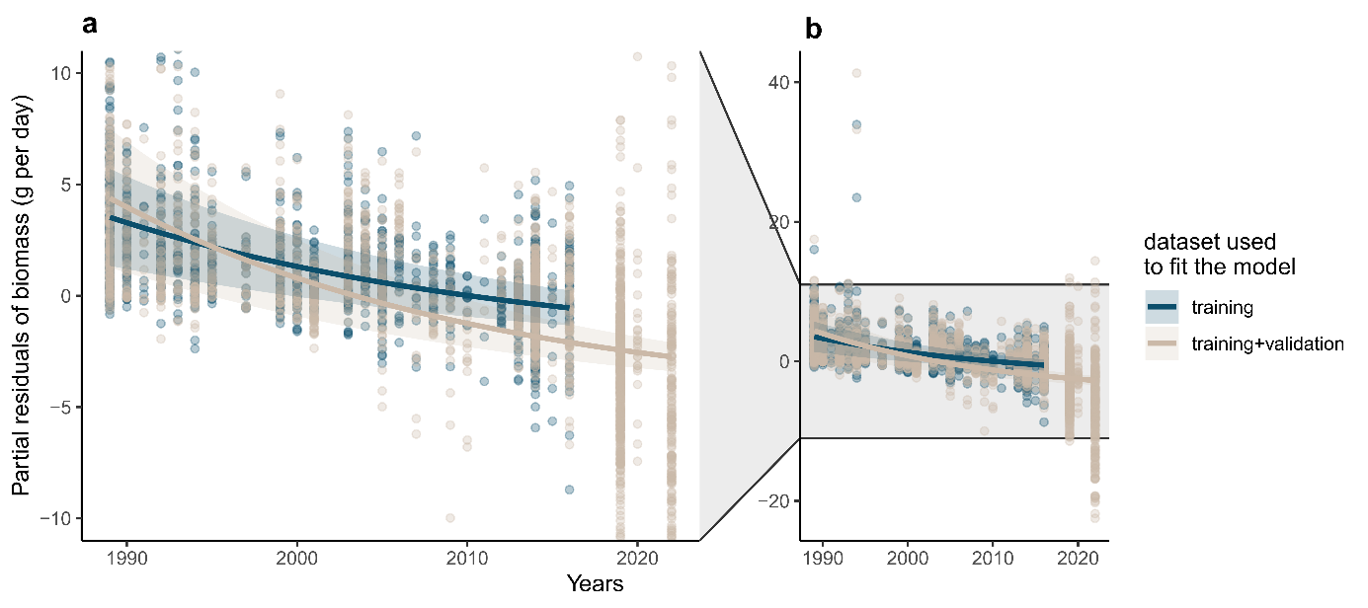Including the additional recent dataset, used as a validation dataset in Müller *et al.*, my results show that the weather-independent temporal trend was even more negative when including recent data (-4.8%.year-1) than with the dataset of Hallmann *et al.* only (Fig. 2). This suggests that the apparent increase in insect biomass between 2016 and 2022 (Fig. 1) was due to spatial heterogeneity in sampling and/or to weather conditions on those years.

***Fig. 2: The temporal trend in insect biomass is significantly negative when the effects of weather are accounted for.*** *Panel (a) is a zoom on the y-axis of panel (b), to improve readability, which is reduced by outliers. Both panels show the partial residuals of biomass, i.e. the amount of biomass not explained by other predictors, as a function of year, when using the training dataset only (blue, from Hallmann et al., 1989-2016) or the training and validation datasets together (beige, 1989-2022), to fit the model. Lines and ribbons show the model prediction and its 95% confidence interval.*

***Table 1: Model estimates and goodness of fit for the model of Müller et al. and for the modified version, with an additional linear year effect.***

|  |  |  |  |  |  |  |
| --- | --- | --- | --- | --- | --- | --- |
| Variable | Model 5 from Müller et al. | | | Modified model 5 | | |
| Estimate | Stde | p-value | Estimate | Stde | p-value |
| Number of herb species | 0.0008 | 0.0011 | 0.4763 | -0.0022 | 0.0011 | **0.0377** |
| Number of tree species | 0.1174 | 0.0121 | **0.0000** | 0.0515 | 0.0143 | **0.0003** |
| Ellenberg value light | 0.1469 | 0.0646 | **0.0232** | 0.0529 | 0.0635 | 0.4051 |
| Ellenberg value temperature | -0.0351 | 0.0406 | 0.3867 | 0.0702 | 0.0408 | 0.0857 |
| Proportion of arable land | -0.3530 | 0.1108 | **0.0015** | -0.0808 | 0.1130 | 0.4746 |
| Proportion of forest | -0.1493 | 0.1139 | 0.1899 | 0.0630 | 0.1139 | 0.5803 |
| Proportion of grassland | 0.3484 | 0.1161 | **0.0027** | 0.2487 | 0.1129 | **0.0277** |
| Proportion of water | 0.2816 | 0.1479 | 0.0571 | 0.0364 | 0.1448 | 0.8016 |
| \**T* | 0.0814 | 0.0062 | **0.0000** | 0.0844 | 0.0060 | **0.0000** |
| \**P* | -0.0033 | 0.0008 | **0.0000** | -0.0025 | 0.0007 | **0.0007** |
| \**T* × *P* | -0.0001 | 0.0002 | 0.7482 | 0.0000 | 0.0002 | 0.8560 |
| \**T* ano. winter | -0.2943 | 0.0268 | **0.0000** | -0.1232 | 0.0321 | **0.0001** |
| \**P* ano. winter | 0.0339 | 0.0026 | **0.0000** | 0.0197 | 0.0030 | **0.0000** |
| \**T* ano. winter × *P* ano. winter | -0.0114 | 0.0025 | **0.0000** | -0.0021 | 0.0026 | 0.4187 |
| \**T* ano. April cur | 0.0820 | 0.0261 | **0.0017** | 0.0810 | 0.0237 | **0.0007** |
| \**P* ano. April cur | 0.0148 | 0.0016 | **0.0000** | 0.0068 | 0.0017 | **0.0000** |
| \**T* ano. April cur × *P* ano. April cur | -0.0028 | 0.0009 | **0.0036** | -0.0003 | 0.0009 | 0.7761 |
| \**T* ano. April prev. | -0.1082 | 0.0303 | **0.0004** | 0.0155 | 0.0301 | 0.6073 |
| \**P* ano. April prev. | 0.0021 | 0.0015 | 0.1477 | 0.0028 | 0.0014 | **0.0405** |
| \**T* ano. April prev. × *P* ano. April prev. | -0.0044 | 0.0008 | **0.0000** | -0.0014 | 0.0008 | 0.0932 |
| \**T* ano. month prev. | -0.0078 | 0.0119 | 0.5135 | -0.0059 | 0.0117 | 0.6134 |
| \**P* ano. month prev. | -0.0009 | 0.0004 | **0.0369** | -0.0001 | 0.0004 | 0.7498 |
| \**T* ano. month prev. × *P* ano. month prev. | -0.0006 | 0.0003 | **0.0419** | -0.0001 | 0.0003 | 0.7196 |
| Year | not included | | | -0.0411 | 0.0048 | **0.0000** |
| R2 | 0.6543 | | | 0.6661 | | |
| AIC | 13156.2570 | | | 13101.6760 | | |

*T*, temperature; *P*, precipitation; ano., anomalies; cur, year of sampling; prev., the month of the sampling day but in the previous year; Stde, Standard Error. Bold pvalues highlight significant effects (p-value < 0.05) and brightness of the color of the “Estimate” column is proportional to the magnitude of the estimate (red for negative and blue for positive effects).

## Habitat conditions played a significant role in the decline of insect biomass

Third, the Müller *et al.* claimed to show that weather conditions are the main drivers of the temporal changes in insect biomass, whereas temporal changes in habitat conditions played a minor role only. However, since weather conditions, as insect biomass, exhibits strong inter-annual variations, weather conditions could drive inter-annual variability in insect biomass without being the main driver of the long-term temporal decline observed by Hallmann *et al.*2. In contrast, habitats conditions measured here (number of trees, proportion of arable land in a 200m radius, etc.) are unlikely to exhibit strong interannual variations, and thus to explain inter-annual variability in insect biomass, but could be an important driver of the long-term trend.

To estimate the contributions of weather and habitat conditions in the long-term biomass decline, I estimated the temporal trend in partial predicts. I predicted biomass according to weather conditions or habitat conditions only and calculated the temporal trend in those values. The results show that weather conditions indeed played a role in the decline observed previously by Hallmann *et al.* (-1.4%.year-1, CI95%=[-1.57,-1.26]), but habitat conditions modelled by Müller *et al.* also played a significant role in that decline (-0.9%.year-1, CI95%=[-1.01,-0.78]). However, these contributions to the long-term decline in insect biomass are minors relative to the part of the decline that correlates more with time than with other included drivers, i.e. the remaining temporal trend (-4.0%.year-1) estimated by the year effect, as said previously.

One would also note the difference in the precision of modelling weather and habitat conditions. While weather conditions are modelled using 12 parameters, including time-lagged effects and interaction among variables, habitats conditions are modelled using 8 parameters, without time-lagged effects or interactions among variables. Some variables, extracted from Hallmann *et al.*, were based on a very coarse temporal resolution. For example, proportion of habitats within the 200m radius have been calculated from two sets of aerial images, taken in 1989–1994 and 2012–2015, and yearly values have been interpolated. Although it is a noble effort to model past habitat changes while there is almost no available data at such spatio-temporal scales, it's an illusion to believe that it captures all the effects of habitat conditions on insect biomass.

Among these variables none of them measure the effect of agricultural intensification, which has been documented as a cause of the insect plight3–5, and abundance changes in other taxa6. Thus, in contrast to what Müller *et al.* wrote, the significant temporal decline in insect biomass, independent from the effect of weather conditions and from modelled habitat conditions, could be explained by unmodelled temporal changes in habitat conditions. The conclusion “*temporal changes in habitat conditions played only a minor role*” in the temporal changes of insect biomass, is therefore surprising and unwarranted.

***Fig. 3: temporal changes in weather and habitats conditions are linked to decline in insect biomass.*** *Biomass values predicted by weather (a) or habitat (b) conditions only, using the modified model presented in Table 1, as a function of the time. The temporal trend in those values (line) is the contribution of those conditions to the long-term temporal trend in insect biomass.*

## Conclusion

In writing this comment, I do not intend to tone down the effects of weather conditions on insect biomass; they are clearly demonstrated by Müller al.’s analysis, and have been supported by other studies7,8. Analyses done by Müller *et al.* show that weather conditions strongly affect inter-annual variability in insect biomass, consistently with previous findings9–13, and that weather conditions could partially drive the observed decline in insect biomass. However, their analyses are not suited to affirm that weather conditions were the only driver of the observed decline, neither to affirm that habitats conditions played a minor role in that decline. Corrected analyses even show the opposite: most of the temporal decline in insect biomass remains unexplained by the available and habitats conditions played a significant role in that decline. Such kind of illegitimate conclusions, minimizing the contribution of land use change in the long-term trend of insect biomass, can be strongly deleterious for biodiversity conservation.

By this comment, I would like to remind our modest ability to model complex ecological changes. Müller *et al.* push forward in the right direction in trying to understand the drivers of the temporal decline in insect biomass using correlates with for which causal mechanisms on the response variable are theorized. However, not accounting for the missing predictors, through a time effect, is likely to produce highly biased results. Assessing the relative importance of drivers requires models that simultaneously include all drivers in a similar way. Since most of the global change drivers exhibit high correlation with time, this remains a challenging task. Moreover, the effects of global change drivers likely depend on each other, e.g. the effect of climate change on insect abundance is mediated by land use8. I thus stress the need to be conservative in the interpretation of results, to prevent overinterpretation of analyses that often come with many limitations, especially when analysing large scale ecological patterns. Drawing conclusions that are not properly supported by statistical findings is likely to disrupt both the scientific debate and public outreach, with possible negative consequences for the trust in scientific results on important topics for societies.

# Acknowledgement

I thank the authors of the original study, Müller *et al.*, for providing R codes and data allowing a good reproducibility of their analyses, and for their comprehensive answer. I also thank Emmanuelle Porcher, Colin Fontaine, Benoit Fontaine and Mathilde Vimont for their helpful comments on this manuscript. I am funded by the European Research Council (ERC) under the European Union’s Horizon 2020 research and innovation program (grant agreement N° 787638, led by C. H. Graham).

# References

1. Müller, J. *et al.* Weather explains the decline and rise of insect biomass over 34 years. *Nature* 1–6 (2023) doi:10.1038/s41586-023-06402-z.

2. Hallmann, C. A. *et al.* More than 75 percent decline over 27 years in total flying insect biomass in protected areas. *PLOS ONE* **12**, e0185809 (2017).

3. Barmentlo, S. H. *et al.* Experimental evidence for neonicotinoid driven decline in aquatic emerging insects. *Proceedings of the National Academy of Sciences* **118**, e2105692118 (2021).

4. Raven, P. H. & Wagner, D. L. Agricultural intensification and climate change are rapidly decreasing insect biodiversity. *Proceedings of the National Academy of Sciences* **118**, e2002548117 (2021).

5. Duchenne, F. *et al.* Long-term effects of global change on occupancy and flight period of wild bees in Belgium. *Global Change Biology* **26**, 6753–6766 (2020).

6. Rigal, S. *et al.* Farmland practices are driving bird population decline across Europe. *Proceedings of the National Academy of Sciences* **120**, e2216573120 (2023).

7. Lister, B. C. & Garcia, A. Climate-driven declines in arthropod abundance restructure a rainforest food web. *Proceedings of the National Academy of Sciences* **115**, E10397–E10406 (2018).

8. Outhwaite, C. L., McCann, P. & Newbold, T. Agriculture and climate change are reshaping insect biodiversity worldwide. *Nature* **605**, 97–102 (2022).

9. Stack Whitney, K. *et al.* Explicit modeling of abiotic and landscape factors reveals precipitation and forests associated with aphid abundance. *Ecological Applications* **26**, 2600–2610 (2016).

10. Fourcade, Y., Ranius, T. & Öckinger, E. Temperature drives abundance fluctuations, but spatial dynamics is constrained by landscape configuration: Implications for climate-driven range shift in a butterfly. *Journal of Animal Ecology* **86**, 1339–1351 (2017).

11. Roy, D. B., Rothery, P., Moss, D., Pollard, E. & Thomas, J. A. Butterfly numbers and weather: predicting historical trends in abundance and the future effects of climate change. *Journal of Animal Ecology* **70**, 201–217 (2001).

12. Goulson, D., Derwent, L. C., Hanley, M. E., Dunn, D. W. & Abolins, S. R. Predicting calyptrate fly populations from the weather, and probable consequences of climate change. *Journal of Applied Ecology* **42**, 795–804 (2005).

13. Jonas, J. L., Wolesensky, W. & Joern, A. Weather Affects Grasshopper Population Dynamics in Continental Grassland Over Annual and Decadal Periods. *Rangeland Ecology & Management* **68**, 29–39 (2015).